 | Jaipuria Institute of Management,  Vineet Khand, Gomti Nagar  Lucknow – 226010

Academic Year | 2026-27
Batch | 2025-2027
Trimester | 4
Programme  (PGDM / PGDM-FS / PGDM-RM) | PGDM
Name of Course | Strategic Management
Section | B
Name of Faculty | Prof. Vir Ved Ratna

Nature of Submission  (Group Assignment / Group Project Report) | Group Project
Topic of Group Assignment / Group Project | AI-Assisted Group Project
Deadline for Submission | 20th September,2026
Group/ Learning Team Number | LT B06
Maximum Marks Allotted | 30

Tick on appropriate
We hereby declare that this project/assignment does not contain any AI generated content (e.g. ChatGPT etc.)
I We hereby declare that this project/assignment has used AI generated content (e.g. ChatGPT etc.) as supporting resource for the completion of project/assignment.

Contribution of Group/LT members in the Assignment/Project
Sl. No. | Name & Enroll. No. of Student | Contribution | Signature
1 | Rameesha Fazal (JL25PG134) | 100% | 
2 | Shruti Chaurasia (JL25PG180) | 100% | 
3 | Samarth Pathak (JL25PG150) | 100% | 
4 | Shaswat Tejpal (JL25PG169) | 100% | 
5 | Sakshi Pandey (JL25PG149) | 100% | 
6 | Shahnawaz Alam (JL25PG163) | 100% | 

Date of receiving at PMC: | Signature of PMC Staff:
Penalty [Marks to be deducted (if any)]:

ANALYTICS AND PYTHON FOR BUSINESS ANALYTICS
Conceptual Knowledge Demonstrated Through the Rossmann Christmas Footfall Prediction Project
Expanded Academic Report

This report will provide an understanding of the concepts of analytics and how Python can be utilized in the Rossmann Christmas Footfall Prediction project. It is deliberately not a regurgitated "concept followed by application" format. The discussion starts with the business problem and follows the flow of information through the analytical pipeline, looks at the rationale for some of the key modelling decisions, and concludes with a business-analytics interpretation of the results.

The aim of Step 5 is NOT to duplicate the whole modelling notebook. Rather, it illustrates conceptual understanding—how certain analytical concepts were necessary, what problems each of these concepts addressed, how each concept was applied in this project, and what conclusions can and cannot be drawn from the evidence produced.

1. Introduction: Analytics as a Decision Process
Business analytics is a formal approach to transforming raw information into evidence to aid business decisions. The analytical quality is related to the relationship between the technical tools and the decision problem; these tools can be data manipulation tools, statistical exploration tools, visualization tools, and machine learning tools.
The main business question for the Rossmann project was: what was the volume of customers during the Christmas shopping season? Footfall is an important factor to consider when determining the operating needs of any store, as a store with unusually high footfall may need to have more staff, more cashiers, more food, etc. on hand. The project wasn't built to account for an exact prediction of the number of customers on each day in the future, however. Rather it asked if a given store day should be marked as being unusually busy when compared to the traffic that the store experiences on an average day.
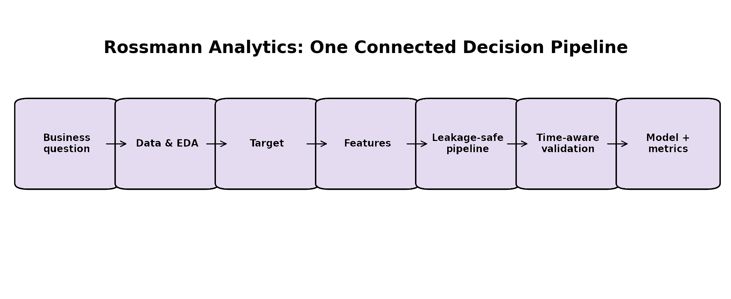
Figure 1. The Rossmann project as one connected analytics pipeline.

This is a significant difference. If the goal was to predict a numerical value for Customers, then the metrics used to evaluate the model would have been regression-oriented, and the model would have tried to predict Customers. The project implemented instead resulted in a binary classification target (High Footfall). This enabled the output to be more readily translated to a readiness alert.

The core analytical question is: If you knew all of the data for a given store-day just before that day was observed, would the model be able to determine if that store-day was likely to be an unusually high footfall for December 1-24? Several concepts had to converge to answer this question. Data needs to be comprehended prior to modelling.

Some goals needed to be created to be meaningful. Information available at prediction time had to be represented by features. Any leakage needed to be avoided. For validation the time structure needed to be respected. Multiple models needed to be evaluated within a single evaluation framework and the last outlier needed to be distinct from the model selection.

2. Data Understanding: Establishing What the Dataset Can Actually Tell Us
The first step of any analytics project is data understanding. Prior to algorithm application, an analyst must be familiar with the unit of observation, the variables available, the time coverage, the size of a data set, the missingness patterns, and categorical variables and the business meaning of key columns. A data set that is incorrect, even though the model is technically correct, will provide you with a wrong answer.
The full dataset of Rossmann stores included 1,115 stores with 1,017,209 observations that span from January 2013 to July 2015. The store dataset had 1,115 store level records. The Christmas prediction window (1st – 24th December) was then picked out and open store observations were used in the modelling process.
Data element | Role in the analysis | Analytical importance
Store | Identifies the retail unit. | Needed because traffic differs substantially across stores.
Date | Provides the temporal structure. | Required to isolate Christmas and create time-related features.
Customers | Observed footfall/outcome source. | Used to construct High_Footfall, but excluded from X.
Sales | Same-day business outcome. | Excluded because it would not be a legitimate advance predictor.
Promo / Promo2 | Promotion conditions. | Potential demand-related predictors.
SchoolHoliday / StateHoliday | Holiday context. | Represents calendar conditions affecting shopping behaviour.
Competition fields | Competitive environment. | Represents store surroundings and competition status.
StoreType / Assortment | Store characteristics. | Represents structural differences between stores.

Also, in the data-understanding step, data types, missing values and duplicates were inspected; and Date was transformed into a usable date representation. They are simple operations to look at but can create analytical problems because a mis-entered date, a missing value, or a misunderstood categorical field can cause problems for subsequent operations.

One of the key points that the project made is that data quality does not equal data cleanliness. A valid value may not be analytically appropriate. The target is built by Customers, so it is not a valid predictor of the final classification, whereas the column Customers is valid. So, when you have to understand a variable, you must understand what it contains and when it is available.

3. Exploratory Data Analysis: Looking for Structure Before Modelling
Exploratory Data Analysis (EDA) is a systematic study of data distributions, patterns, relationships and unusual observations. EDA is frequently thought of as charts, but it serves a greater purpose when developing and testing expectations of the data prior to formal modelling. The exploratory study of Rossmann focused on the distribution of Customers, the development of the footfall during December, the difference between December and January, the difference between weekday and weekend, promotion versus non-promotion, store-type difference, class distribution and relationships between variables.
During the exploration process, correlation analysis was also utilized. For instance, if the data was distributed among Customers, it would be helpful to determine if there is enough reason to have a universal numerical threshold. A threshold of say, “more than 1,000 customers equals high footfall” might be very different between stores if one store would see several thousand customers and another only a few hundred.
EDA question | What it reveals | Connection to later modelling
How is Customers distributed? | Spread, skewness and extreme values. | Supports target design and cautions against a single absolute threshold.
Does traffic change through December? | Possible progression toward Christmas. | Motivates DaysToChristmas.
Do promotions correspond to different patterns? | Association between promotional status and traffic. | Supports Promo-related predictors.
Do store types behave differently? | Structural heterogeneity across stores. | Supports StoreType and Assortment.
Is the target severely imbalanced? | Relative frequency of classes. | Informs whether special imbalance methods are necessary.
Do numerical variables move together? | Potential relationships and redundancy. | Supports exploratory understanding of the predictor space.

This observation is in line with the eventual store-relative percentile approach. Likewise, looking at the development of December offers a justification to think about Days to Christmas. Two days of the week with the same name may be in different demand states, one a day before Christmas, the other a day early in December.
EDA was not used as proof of causality in the project. For example, if there is a relationship between increased footfalls and promotional days, it does not necessarily mean that promotions are responsible for footfalls. EDA does not set causal relations rather it sets patterns to be modeled.

4. Defining “High Footfall” Through Relative Behaviour

One of the most critical analyses decisions an algorithm must make in a classification problem is the target variable. A target should be specific to the business phenomenon and easy to understand the prediction made by the model. Percentiles are particularly helpful when the interest is a relative one, not an absolute one.

The 75th percentile, or P75, is a data value for which three quarters of the data values in the reference data set are at or below this value. The Rossmann project implemented the following idea to create an unusually high day separately for each store. The final modelling design used an open-store observation of each store between January and November of the same year to calculate the store's P75.
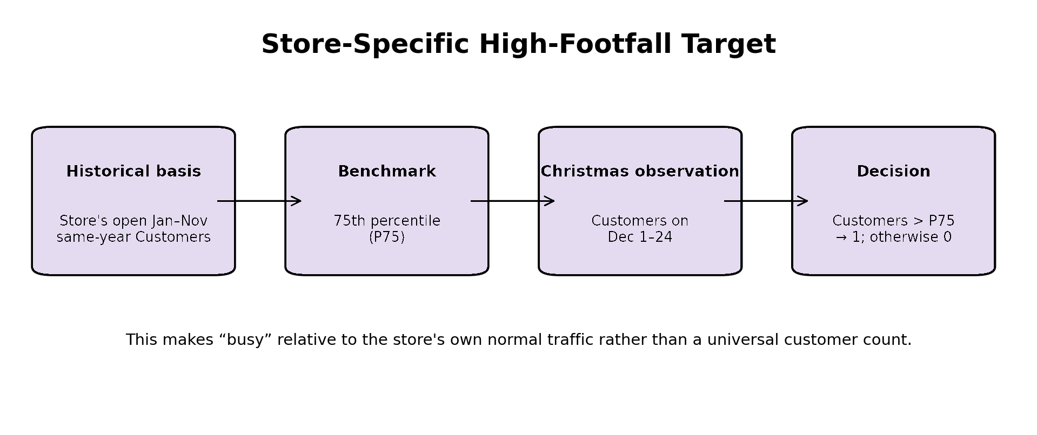
Figure 2. Store-specific construction of the High_Footfall classification.
There was a strict rule about the Christmas period - High_Footfall = 1 if Customers > store-specific P75 then it was 0. The use of “greater than” is important because an observation that is equal to the threshold is not considered to be high.
Example: If there are 800 customers at Store A at P75. If 950 customers use a store on a given day of Christmas, it is day of Christmas 1, and if 790 customers use a store on a given day of Christmas, it is day of Christmas 0.
Under the strict final rule, a day that has exactly 800 customers is also considered to be labeled 0.
The problem of comparability is addressed in this target construction. Many variables including store characteristics and location determine a store's normal traffic. If you have the same number of absolute customers, that might be a lot for one store, but just right for another. High footfall is thus a relative deviation from the store's own historical footfall distribution, and the percentile is used to express this.

Possible target design | Problem | Why the final design is preferable for this project
One universal customer threshold | Treats all stores as if they have identical normal traffic. | Ignores store-level differences.
Global Christmas-period P75 | Uses the prediction period itself to define the benchmark. | Less aligned with advance prediction and store-specific behaviour.
Store-specific Jan–Nov P75 | Uses historical same-year store behaviour. | Creates a relative, store-specific benchmark using pre-Christmas history.

This target is important in that it does not forecast the level of demand. A model prediction that High_Footfall = 1 does not imply that the store will get a certain number more customers for that day of the week, it only implies that it is likely to get more customers than its high traffic benchmark that day.

5. Feature Engineering: Translating Retail Conditions into Predictors
Feature engineering is the process of representing raw business information in variables that a machine-learning model can use. In the practice of analytics, this is sometimes referred to as "encoding" or "categorizing" dates, operational conditions and categorical attributes into structured predictors that capture the underlying business process.
The final set of features for Rossmann had 13 predictors. These predictors can be categorized into five analytical themes: timing, promotion, holidays, competition and store characteristics.
Theme | Variables in the final predictor set | What the theme represents
Timing | DayOfWeek; DaysToChristmas | The position of a store-day within the weekly and Christmas calendar.
Promotion | Promo; Promo2; Promo2Active | Promotional environment relevant to the store-day.
Holiday | SchoolHoliday; StateHoliday | Holiday-related demand context.
Competition | CompetitionDistance; CompetitionAgeMonths; CompetitionHistoryKnown; CompetitionActive | Competitive environment and whether competition is active/known.
Store structure | StoreType; Assortment | Persistent differences in store format and product offering.

A good example of feature engineering is the DaysToChristmas feature. A Date is a calendar identifier that does not contain any other identifier. DaysToChristmas transforms that date into a distance based on a business focus. Thus, the transformation simplifies the use of temporal information by a model. Another principle demonstrated in CompetitionAgeMonths and CompetitionActive is that raw data can be rendered as a view of business status.

There's more context in the distance from a competitor than an isolated store; the age of the competitive relationship, as well as whether competition is active. The distinction between exploration and ultimate implementation: A previous day/previous week customer variable was explored in an earlier exploration notebook. These were not put in place in the final baseline. The 13 predictors listed above are thus the actual feature set in the reported modelling workflow in the final Step 5 discussion.

6. The Information Boundary and the Problem of Data Leakage
Among the many concepts of predictive analytics, data leakage is one of the most significant, as it may lead to very accurate models that cannot be effectively applied in the real world. Leakage refers to information that is not known at prediction time that is fed into the model. The most obvious being customers.
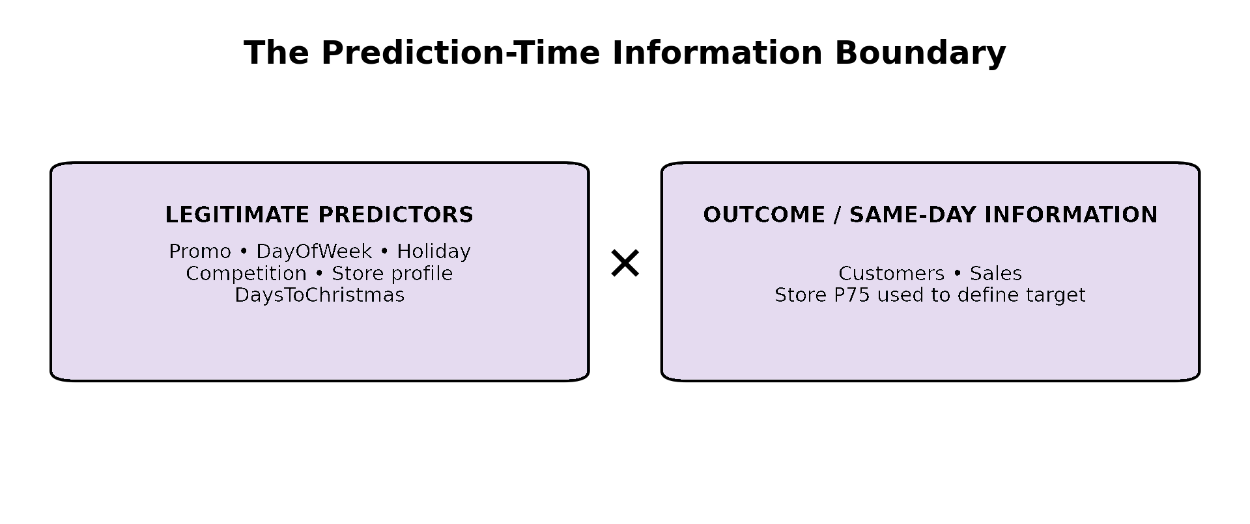
Figure 3. The information boundary enforced by the Rossmann modelling design.
As defined by Customers, giving the model Customers will in effect give the target. The model would not be predicting the busyness of the day, but it would be predicting the answer to the question from the outcome variable. The exclusion in sales was also since it is considered a same-day result, hence not significant for this research.
Same day Sales cannot be used as an advance predictor when the object is to identify an unusually busy day prior to when the traffic of that day has been observed. One of the other sensitive fields was store_p75_customers. It was not a predictor in the predictor matrix, but it was required for construction of the target. It's important to notice that this illustrates an important principle that a variable may be valid as a label, but not as a predictor.

Variable | Why it exists in the project | Why it is not a final predictor
Customers | Observed customer footfall and basis of the label. | It directly defines High_Footfall.
Sales | Observed daily sales. | Same-day outcome information.
Store_P75_Customers | Historical benchmark for target construction. | Target-generation information rather than a predictor in the final matrix.
Store ID | Store identifier. | Not treated as a substantive numerical predictor in this design.
Date | Temporal identifier. | Its predictive meaning was represented through engineered calendar features.

The modelling task was then shifted from an easy task that was not valid, to a more difficult and operationally meaningful task of leakage prevention. This is one of the most important lessons in business analytics - it's about predictive validity, not just an artificially raised score.

7. Preprocessing: Making Mixed Business Data Model-Ready
Typically, a retail dataset will have a combination of numerical and categorical variables. In most cases, machine learning algorithms need a set of numbers, so the data needs to be preprocessed. Imputation is used for missing data, scaling is used to standardize numerical variables and encoding is used to transform categories into indicators.
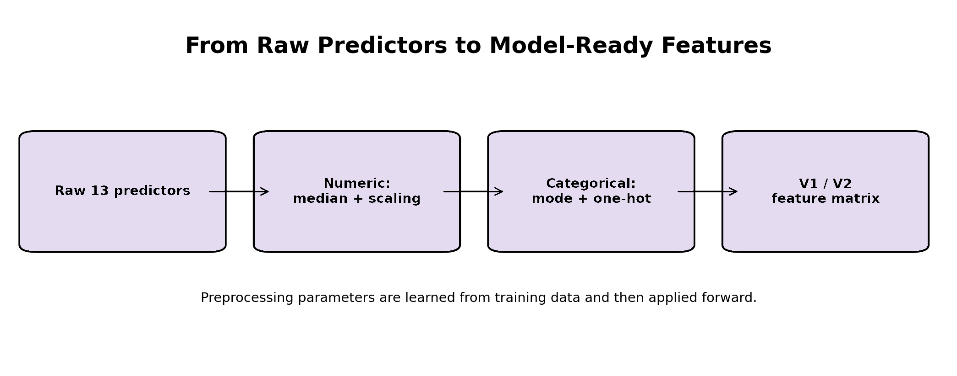
Figure 4. The preprocessing path from the 13 final predictors to model-ready features.
If the variable is numerical, then median imputation and standard scaling was done on the project. Median imputation is more robust than mean imputation in the presence of extreme values and offers an easy alternative to missing numerical values. Standard scaling is used to put a scale on a numerical variable that is like other numerical variables. Most-frequent imputation and one-hot encoding were used for categorical predictors.
One-hot encoding is binary indicator columns for a category. For instance, instead of StoreType having some kind of numbers assigned to represent it, you can use separate indicators for the various possible Stores.
Unrecognized categories were set to not be used for scoring. This is real protection since a category that is present in future data might not be present in the training data. A significant methodological issue is the learning of pre-processing from training data.
Future information may leak back into model development if a model is fitted with the help of future information provided by an imputer, scaler or feature-selection step. The project incorporated the preprocessing step into the modelling process and placed the feature selection step inside each validation fold.

8. V1 and V2: Testing the Value of Feature Reduction
Feature selection is a method for keeping a subset of the available predictors (or encoded columns) based on a specific criterion. It might decrease the dimensionality of the model, eliminate less valuable information and in some cases enhance generalization.
But feature selection is another modelling choice and should also be validated. The project made an intentional comparison between two representations. V1 utilized all the features that have been preprocessed. V2 applied SelectFromModel with a different Random Forest importance model and kept the columns that are encoded and have importance above the mean-importance threshold.
Configuration | Meaning | Observed RF validation result
RF V1 | Random Forest with all preprocessed features. | Mean F1 = 0.531; ROC-AUC = 0.764.
RF V2 | Random Forest after model-based feature selection. | Mean F1 = 0.386; ROC-AUC = 0.709.

Such a comparison makes sense for answering the following practical question: does the simplicity of the representation lead to better prediction? If V2 had consistently performed better than V1, then there would be some evidence of usefulness of feature reduction. For the actual validation results, RF V1 has the highest mean F1 score, and RF V2 has a much lower score.
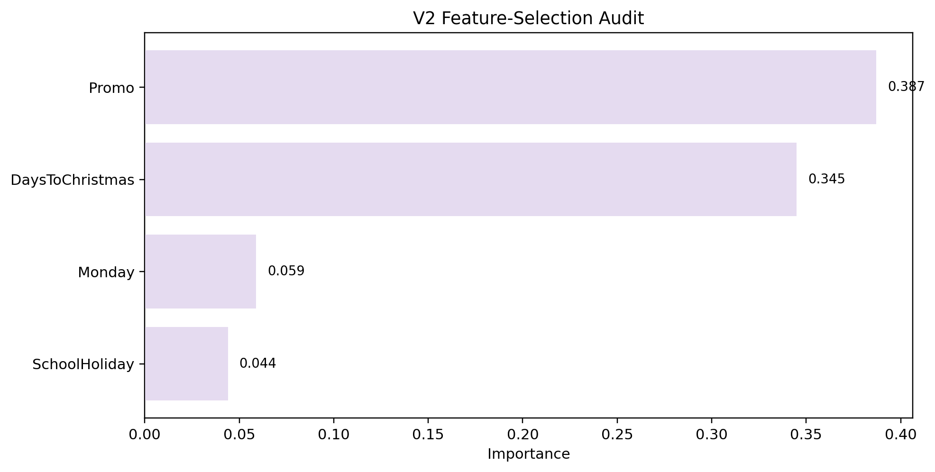
Figure 5. Feature-selection audit for the retained encoded predictors.

9. Classification Models: Why Four Algorithms Were Compared
Comparing and contrasting models are methods of analytical experimentation. There is more than one type of algorithm that can capture the structures in the same data, and so it would not be sufficient to say that a model was taken because it was used in other projects.
Logistic Regression is a relatively simple classification relationship. Decision Trees use sequential rules for dividing the predictor space. Random Forest combines multiple decision trees, which gives it the ability to capture nonlinear patterns, but also minimizes reliance on a single decision tree. Gradient Boosting creates trees one by one, with each tree's emphasis placed on previous tree mistakes
Model | Underlying idea | What it tests in this project
Logistic Regression | Linear decision relationship in transformed predictor space. | Whether a relatively simple boundary can separate high and normal days.
Decision Tree | Recursive rule-based partitioning. | Whether direct nonlinear thresholds are useful.
Random Forest | Ensemble of many trees. | Whether aggregated nonlinear relationships improve robustness.
Gradient Boosting | Sequential ensemble learning. | Whether iterative error correction captures useful structure.

A dummy baseline was also used. A baseline is important because a machine-learning model should perform better than a simple comparison approach. An accuracy number is less meaningful if it doesn't have some context.

V1 and V2 were used to test each substantive algorithm. This resulted in a total of eight candidate configurations. Thus, both algorithm family and feature representation were evaluated under a common validation procedure on the project.

10. Validation Metrics: Looking Beyond Accuracy
There are many ways to test a classification model. Accuracy measures the percentage of model's correct answers and does not differentiate between the various kinds of errors. Operational consequences of false positive and false negative alerts are different in a busy-store alert system.
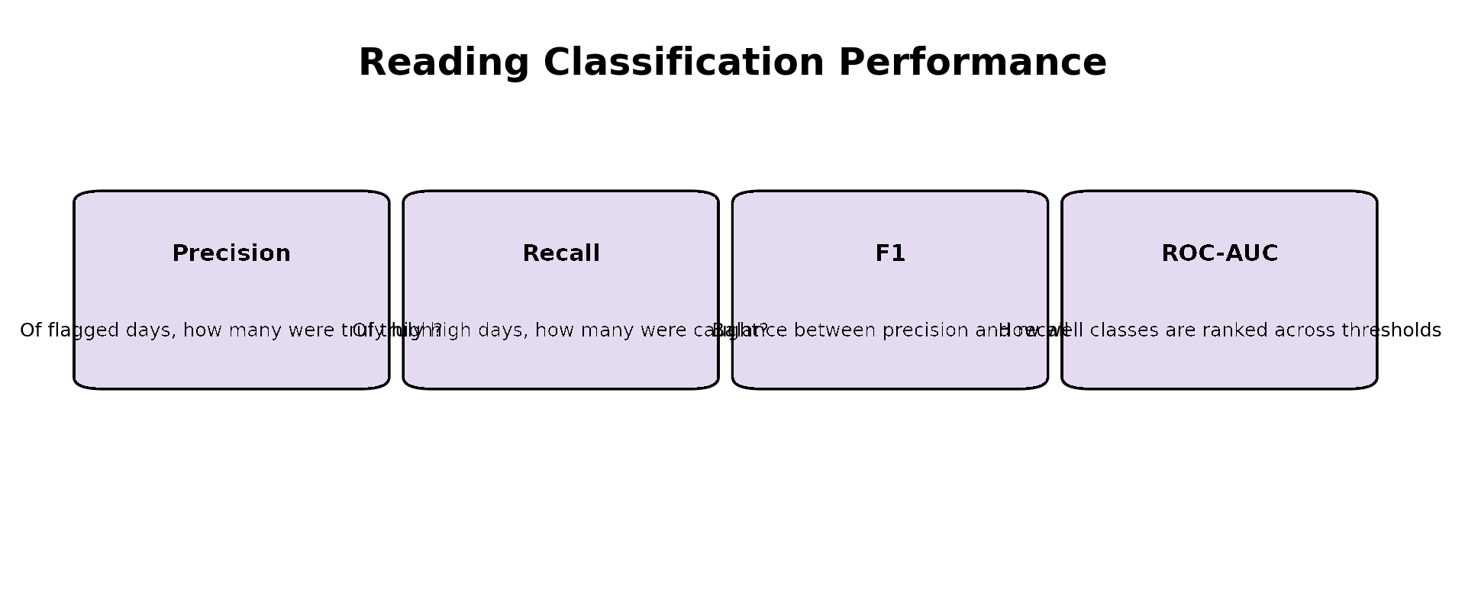
Figure 6. The main classification metrics and the question each one answers.
Precision is the percent of predictions that were correct and were high footfall. In business jargon, it means that the reliability of an alert. Recall is the percentage of the actual high footfall observations that the model recognizes. In business words, the measure of busy opportunities that are captured. The harmonic meaning of precision and recall is F1.
It works well when the analyst wishes to have a balance and a single measure is not to become predominant. The project thus employed mean validation F1 as the main model-selection criteria. ROC-AUC indicates the ability of the model to differentiate between classes across all thresholds. It should not be viewed as a score for calibration of probabilities.
The higher the ROC-AUC, the more likely positive cases are to get higher scores than negative cases, but this does not necessarily imply that the predicted probabilities are accurately calibrated.

Metric | Formula / interpretation | Rossmann relevance
Accuracy | (TP + TN) / Total | Overall correctness.
Precision | TP / (TP + FP) | Reliability of busy-day alerts.
Recall | TP / (TP + FN) | Coverage of genuinely busy days.
F1 | Harmonic mean of precision and recall | Balances false alarms and missed busy days.
ROC-AUC | Area under ROC curve | Overall discrimination across thresholds.

11. Why the Validation Design Determines the Meaning of the Score
The interpretation of a model score must be based on the process of creating the score. With a temporal business problem, a high F1 value for a random split is not equal to a high F1 value for a chronological future-like split.
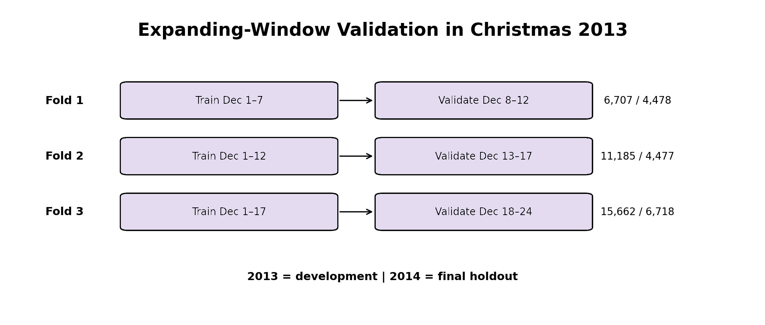
Figure 7. The three expanding chronological validation folds used during development.
This project saw Christmas 2013 as the development period and established three growing training windows. Fold 1 was trained for 5 days (December 1–7) and validated for 5 days (December 8–12). Fold2 was trained from December 1-12 with validation on Dec 13-17. Fold 3 was trained for 10 days between the 1st and 17th of December, and validated for 10 days between the 18th and 24th of December.
Fold | Training rows | Validation rows | Analytical interpretation
1 | 6,707 | 4,478 | Early-period learning tested on the next Christmas segment.
2 | 11,185 | 4,477 | More history available before the next validation segment.
3 | 15,662 | 6,718 | Largest development window tested on the final 2013 segment.

The growing structure is convenient since it reflects how an operational model might be updated as additional data from December observations were collected. This also lets the analyst determine if any changes in performance occur over the Christmas period.

12. Model Selection: Evidence Before the Final Test
The selection rule was the highest mean validation F1 score and ROC-AUC was used as tie-breaker. This is an example of analytical governance: the criterion is determined beforehand before the final holdout is looked at.
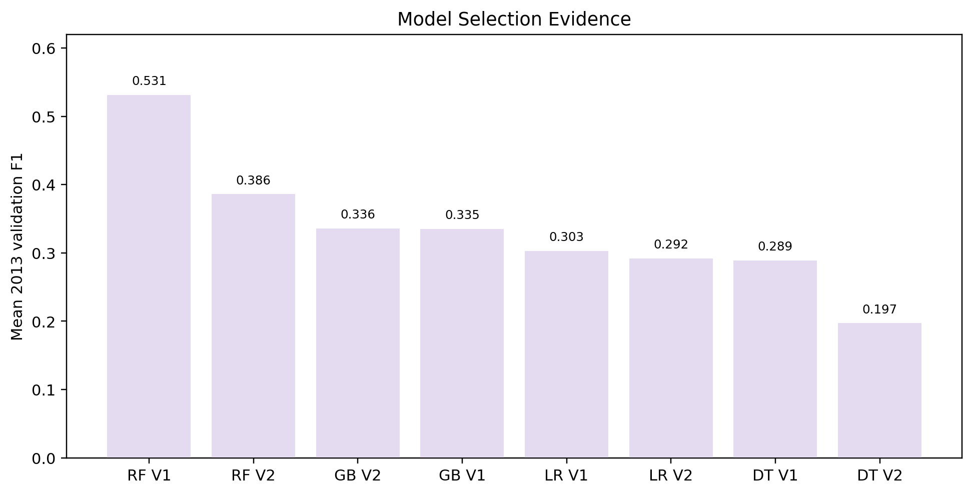
Figure 8. Mean validation F1 across the eight substantive candidate configurations.
Candidate | Mean Accuracy | Mean Precision | Mean Recall | Mean F1 | Mean ROC-AUC
RF V1 | .624 | .699 | .521 | .531 | .764
RF V2 | .579 | .330 | .475 | .386 | .709
GB V2 | .636 | .343 | .364 | .336 | .740
GB V1 | .631 | .698 | .314 | .335 | .655
LR V1 | .648 | .686 | .338 | .303 | .773
LR V2 | .646 | .332 | .334 | .292 | .518
DT V1 | .539 | .349 | .256 | .289 | .590
DT V2 | .571 | .328 | .141 | .197 | .601

V1 with Random Forest achieved the highest mean validation F1 value of 0.531. For this reason, it was chosen prior to the 2014 holdout. This is a crucial methodological point, since the holdout should be asked instead, “How did the process selected perform on data that it didn't see before?” instead of “Which model should we choose after seeing every result?”

The reason for this is that in this case, F1: Logistic Regression V1 had a higher mean ROC-AUC of 0.773 than RF V1's 0.764 although the mean F1 value was significantly lower at 0.303. However, F1 was the main selection criterion and LR V1 was not selected.

13. The 2014 Holdout: Final Evidence for the Selected Model
Christmas 2014 was kept as the last holdout after the selection of the model. The separation allows for a clean chronological test – the model selection decision was made based on evidence from 2013, and evidence from 2014 is about the approach chosen.
The 2014 holdout for RF V1 consisted of 19,694 observations of store days. The model achieved 0.810 accuracy, 0.845 precision, 0.825 recall, 0.835 F1 and 0.857 ROC-AUC.
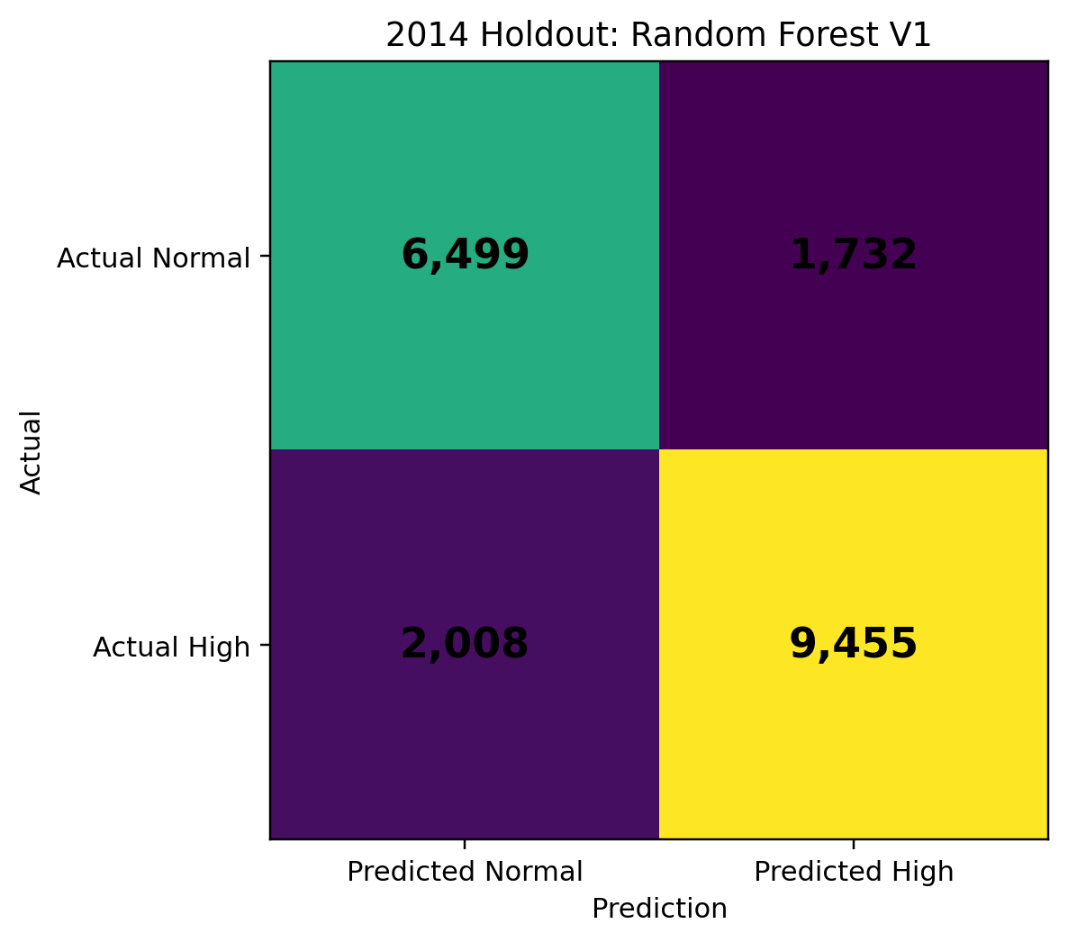
Figure 9. RF V1 confusion matrix on the 2014 final holdout.
Outcome | Count | Percentage / interpretation
True Negative | 6,499 | Correctly classified normal days.
False Positive | 1,732 | Normal days incorrectly flagged as high.
False Negative | 2,008 | High-footfall days missed.
True Positive | 9,455 | High-footfall days correctly detected.

In the 2014 holdout there were 11,463 store-days that had a high foot fall. On about 17.5% of actual high footfall days (2,008) a false negative occurred. This is important as the overall F1 can be high and yet a lot of busy days might be lost.

There were also 1,732 false positives. The positive predictions for the model add up to 11,187, which is about 15.5% of the flagged days. From an operational point of view, this would cause some alerts to trigger managers to prepare for a busy period, but without there being one. The confusion matrix then translates a technical score into a management swap.

When the test comes back negative, it could be an opportunity missed on preparing staffing or checkout help. A false positive could be preparation which need not have been done. Numbers of these errors is not quantified in the project, and so it cannot assert that any one is objectively more costly than the other.

14. Understanding Model Stability and Generalisation
A model is said to have generalisation capabilities if its performance is good beyond the observations it was fitted to. If training performance is significantly larger than validation performance, one indicator is that. The other is a large difference between folds.
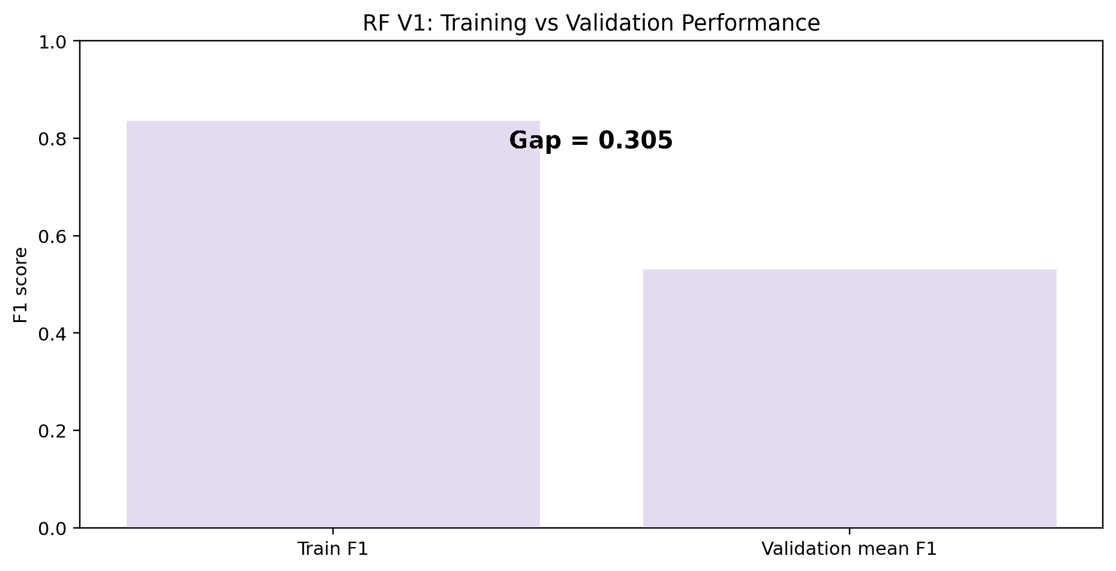
Figure 10. RF V1 training versus mean chronological validation F1.
RF V1 had a training F1 of 0.836 and a mean validation F1 of 0.531, producing a gap of 0.305. There was a validation F1 standard deviation of 0.232. These suggest an overall good model fit of the training observations and that there were no consistent performance differences between model folds. Cautious is the correct interpretation.
Evidence points to potential overfitting and/or changes in traffic flow throughout the Christmas period, but not the specific drivers of the change. Further testing would be required to distinguish effects of model complexity from real time change in demand.
Observed evidence | What it suggests | What it does not prove
Train F1 = 0.836 vs validation F1 = 0.531 | Potential generalisation gap. | Does not by itself prove overfitting is the only cause.
Validation F1 SD = 0.232 | Performance changes materially across folds. | Does not identify the precise source of instability.
2014 F1 = 0.835 | Later holdout performance was substantially stronger. | Does not mean the model is guaranteed to remain equally strong in future years.

This is a valuable business analytics lesson – don't look at the best or final score of a model. That score and the range of scores in the development process and the circumstances of the score are among the evidence.

15. Feature Importance: Understanding Predictive Signal Without Claiming Causality
Feature importance is a model-based measure of usefulness of a variable in the prediction task within a given modelling framework. It does not refer to causal coefficient. The high importance value does not imply that varying the variable will change the number of customers – it is only a sign that the variable has predictive value.
Figure 11. Feature-selection audit for the V2 representation.
Encoded predictor retained | Importance | Correct interpretation
Promo | 0.387 | Strong predictive signal in the feature-selection model.
DaysToChristmas | 0.345 | Strong predictive signal associated with calendar proximity.
Monday | 0.059 | Additional weekday-related predictive information.
SchoolHoliday | 0.044 | Additional holiday-context information.

If, instead, the importance is 0.387, the pie chart doesn't imply that 38.7% of the customers were added because of the promotion. The correct answer is that Promo was very informative class-wise for the feature-selection model. This is an important distinction in a business report as managers are likely to view the variables that are predicted as levers.

Predictive analytics can be used to determine where information is but predicting which intervention will result in a change of business outcome. 16. Python Libraries: Coding Tools to Analytical System. There are libraries in Python to facilitate various stages of the analytical process. Structured data is stored in pandas, numerical operations in NumPy, patterns communicated in visualization libraries and the predictive modelling framework in Scikit-learn, and the interactive environment, where the workflow can be documented and inspected, in Jupyter Notebook.

16. Python Libraries: From Coding Tools to an Analytical System

The Python libraries can be used to implement various stages in the analytical workflow. Structured data is handled by pandas, numerical operations are available in NumPy, communication of patterns is available in visualisation libraries, predictive modelling is available in Scikit-learn and the interactive environment to document and inspect the workflow is provided in Jupyter Notebook..
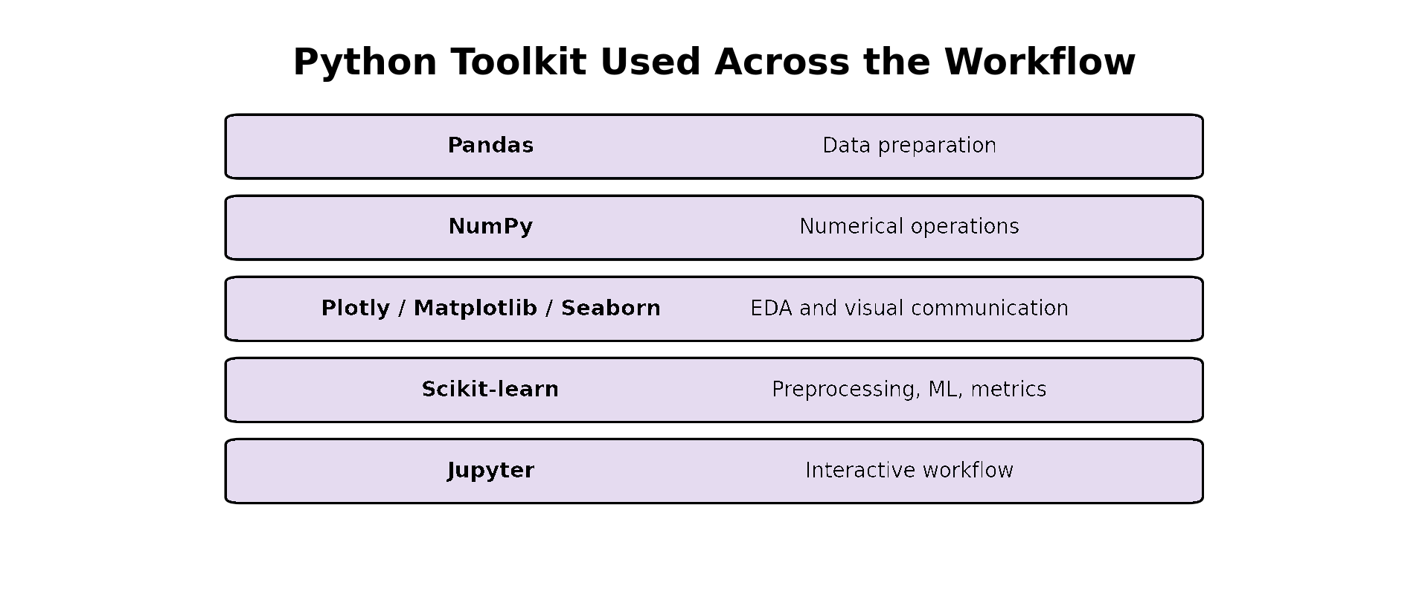
Figure 12. Python tools used across the Rossmann analytical workflow.

Library / environment | Core capability | Rossmann role
Pandas | DataFrames, filtering, grouping, merging, date handling and transformation. | Prepared and reshaped the Rossmann data and engineered the analytical dataset.
NumPy | Numerical arrays and operations. | Supported numerical calculations and conditional transformations.
Plotly | Interactive visualisation. | Used in exploratory notebook outputs for distributions and class comparisons.
Matplotlib | General plotting framework. | Supported visual analysis in the exploratory workflow.
Seaborn | Statistical visualisation. | Supported exploratory distributions and relationship visualisation.
Scikit-learn | Preprocessing, feature selection, ML algorithms and metrics. | Core predictive framework.
Jupyter Notebook | Interactive code + output + explanation. | Used to execute, inspect and document the analytical workflow.

What is important about these tools is the way in which they are connected. A business analyst will never do all data preparation, data visualization and data modelling using a single package. The workflow can be more naturally viewed as a pipeline in which each library is used for a different type of analytical task.
Example workflow: Pandas can preprocess the store-day table; NumPy can handle the numerical operations; Plotly, Matplotlib and Seaborn can reveal patterns in the data during exploration; Scikit-learn can build pipelines for preprocessing, train classifiers and compute evaluation metrics; and Jupyter can capture the order of analysis and outputs.

17. The Integrated Analytics Workflow in the Rossmann Project
The best approach to demonstrating conceptual knowledge is to illustrate how the methods rely on one another. The Rossmann project can be reconstructed as a sequence of decisions that set up the conditions for the next decision in the sequence.
Stage | Analytical idea | Rossmann implementation | Result
1 | Problem framing | Predict unusually high Christmas store-days. | Defined the task as classification.
2 | Data understanding | Inspect structure and meaning. | Identified store-day data, dates, outcomes and predictors.
3 | EDA | Explore distributions and relationships. | Identified temporal, store and promotion patterns.
4 | Target construction | Use a meaningful classification boundary. | Created store-specific same-year Jan–Nov P75 target.
5 | Feature engineering | Represent business conditions. | Created 13 final predictors.
6 | Leakage control | Respect prediction-time information. | Excluded Customers, Sales and target-derived information.
7 | Preprocessing | Create model-ready representations. | Imputation, scaling and one-hot encoding.
8 | Feature selection | Test reduced representation. | Compared V1 with V2.
9 | Model comparison | Test different learning structures. | Four classifiers plus dummy baseline.
10 | Temporal validation | Respect future direction. | Three expanding 2013 folds.
11 | Model selection | Use predefined criterion. | RF V1 selected on mean validation F1.
12 | Holdout evaluation | Test later unseen season. | Christmas 2014.
13 | Error interpretation | Translate statistics into decisions. | FP/FN interpreted as readiness trade-offs.

The workflow is shown to be more than just a series of Python commands. Every computation step is based on an assumption about the analysis. The prediction scope is reflected in filtering to open stores. In fact, creating Days To Christmas illustrates the relevance of proximity to events in the business world. Customers is an information boundary. Chronological validation is a reflection of the problem's time sequence. The number of missed busy days and false alarms is the desired balance, as captured by F1 selection

18. From Prediction to Business Decision Support
The value of a predictive model lies in the ability to use its output in the context of a decision. The Step 4 business solution converted the RF V1 signal into suggested operational readiness actions including staffing coverage review, flexible checkout support and replenishment timing review.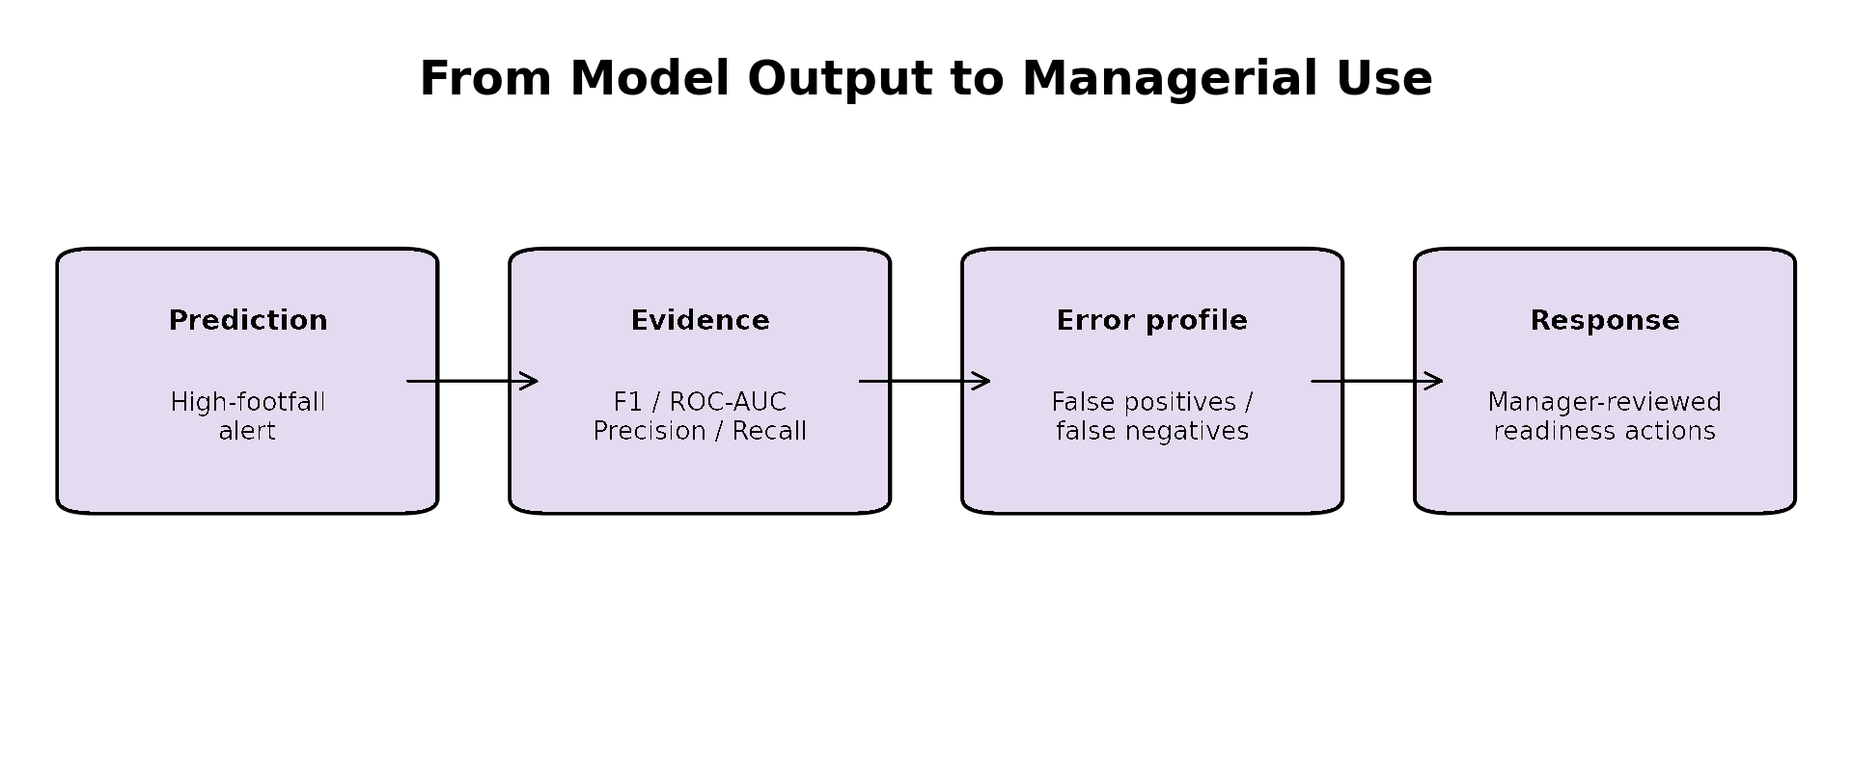
Figure 13. How model evidence can be translated into manager-reviewed operational use.
The model should thus be considered as a layer of decisions support and not as an operating system. The high footfall prediction generates an alert for management review. It does not necessarily mean that it will be the number of employees that will be needed, the number of customers, or that orders for inventory will be placed automatically.
Model output | Possible operational response | Why managerial review remains necessary
High-footfall alert | Review shift coverage. | Actual staffing requirements depend on local conditions.
High-footfall alert | Prepare flexible checkout capacity. | The cost of preparation and actual queue pressure may differ.
High-footfall alert | Review replenishment timing. | Inventory decisions require information beyond the model predictors.

This is crucial for good analytics. The model gives evidence, and managers use that evidence and operational knowledge, constraints, and other information. The model is especially suitable for the project because of the different validations it has experienced.

19. What the Project Teaches About Responsible Model Use
A successful analytics project should not only be able to tell you what went well, it should also tell you what is not clear. The Rossmann model is useful to predict the signal, but there are some limitations.
- Although customer-lag and rolling-traffic variables may be able to account for recent demand momentum, these variables are not included in the final baseline.
- A threshold optimisation based on business costs was not conducted; the classification cutoff was set at 0.5. No formal probability calibration was carried out; model scores do not necessarily represent a "perfect" calibration.
- The hyperparameters used are not necessarily the result of an exhaustive search for hyperparameters.
- The model-selection decision was properly frozen before the 2014 holdout and thus should not be used to retroactively replace the RF V1 model, for better holdout performance of some alternative candidates.
- The analysis does not show cause-and-effect relationships.
The limitations do not preclude the project. Rather, they outline the range of evidence that is supported. The right answer is that the framework chosen gives a good baseline for predicting unusually high Christmas store-days and that there is scope for improvement in the future.

20. Critical Comparison of the Development and Holdout Results
It is very helpful to understand the difference between development evidence and holdout evidence, especially for understanding the behaviour of the model. RF V1 had mean F1 of 0.531 in 2013 chronological validation. The same selected model obtained F1 value of 0.835 for the 2014 holdout. The improvement is significant.
Measure | 2013 mean validation | 2014 holdout | Interpretive point
Accuracy | .624 | .810 | Overall classification was stronger in the later holdout.
Precision | .699 | .845 | Positive alerts were more reliable in 2014.
Recall | .521 | .825 | The model detected a larger share of busy days in 2014.
F1 | .531 | .835 | The balance between precision and recall improved substantially.
ROC-AUC | .764 | .857 | Discrimination was stronger on the 2014 holdout.

The right answer is not to take for granted that the model is generally more effective in 2014. The two evaluation settings are different, and the improvements observed could be due to changes in the distribution of data, the Christmas pattern, the conditions in stores or the specific samples evaluated in the two periods. The result, however, does offer some indication that the model generalised well to the 2014 holdout, compared to its 2013 validation average. This is another argument for maintaining the original selection process.
The improvement would not have been a clean holdout result if the model had been selected based on the data from 2014.

21. Academic Interpretation of the Main Analytical Concepts
The project can also be interpreted through the conceptual language of analytics and machine learning.
Conceptual area | What the project demonstrates
Descriptive analytics | EDA was used to understand what had happened in the historical retail data.
Diagnostic-style exploration | Comparisons across dates, promotions and store characteristics were used to understand patterns.
Predictive analytics | Classification models estimated the likelihood of high-footfall outcomes.
Feature engineering | Raw business information was converted into predictive variables.
Supervised learning | Models learned from labelled store-day observations.
Classification | The outcome was binary: High_Footfall or normal.
Model validation | Chronological folds were used to estimate generalisation during development.
Model selection | F1-first governance identified RF V1.
Error analysis | Confusion-matrix components were translated into operational implications.
Decision support | Predictions were positioned as manager-reviewed alerts rather than autonomous actions.

22. Practical Examples of How the Concepts Interact
The following examples illustrate the need for the concepts not to be considered as separate textbook topics.
- If EDA finds that traffic is significantly different between stores, the design should consider the different behaviour of the stores. This inevitably brings up the P75 benchmark and not the universal customer threshold.
- . If the target is built from Customers, Customers will not be able to be used as a predictor. The leakage-control decision is thus directly related to the construction of the target.
- If the business question is related to the days of the year that the Christmas store is open, random validation is less appropriate. The validation design is then related to the prediction horizon.
- If false alarms are important and busy days are important as well, then accuracy is not sufficient. The operational interpretation of the prediction thus affects the selection metric used primarily, F1.
- If a final holdout is to be used to estimate generalisation, then it is not appropriate to use it to select the winner. The model-selection governance is thus dependent on the purpose of the holdout.
The examples demonstrate logical connections of the analytical workflow. Choices that are made early in the project limit options later on. This is one of the most crucial types of conceptual understanding in business analytics.

23. Overall Learning from the Rossmann Project

The project demonstrates that predictive analytics is not simply an exercise in training a model. A reliable analytical result depends on the chain from problem definition to final interpretation.

First the business question was converted into a measurable store-day classification task. Second exploratory data analysis established that footfall varies across stores and through the Christmas period. Third the target was constructed relative to each store’s behaviour. Fourth the predictor set represented calendar, promotion, holiday, competition and store characteristics. Fifth leakage controls protected the prediction-time information boundary.

The project then created features through imputation, scaling and encoding and compared full and reduced feature representations. Four classifier families were evaluated under validation and F1 was chosen as the primary model-selection criterion. Random Forest V1 emerged as the selected candidate. After that decision was made was the 2014 holdout used for final evaluation.

The final holdout performance provides evidence: Random Forest V1 achieved 0.835 F1 and 0.857 ROC-AUC. However the development results also showed instability with a 0.305 train-validation F1 gap and 0.232 validation F1 standard deviation. A responsible interpretation therefore recognises both the signal and the uncertainty.

From a business-analytics perspective the important outcome is the disciplined workflow. The project shows how Python can be used not merely to run algorithms but to implement a reasoning process in a reproducible and auditable way.

24. Conclusion
The Rossmann Christmas Footfall Prediction project provides a demonstration of conceptual knowledge in analytics and Python for business applications. The project integrates data understanding, exploratory analysis, percentile-based target construction, feature engineering, leakage prevention, preprocessing, feature selection, classification, chronological validation, metric-based model selection, holdout testing and business interpretation.
The key conceptual insight is that each technical decision serves the business problem. The store-specific P75 makes " footfall" meaningful across heterogeneous stores. The feature set represents information that can be known before the outcome. Leakage controls protect validity. Chronological validation respects the forecasting direction. F1 reflects the trade-off between missed days and unnecessary alerts. The protected 2014 holdout provides a later-season evaluation of the selected model.
Python libraries make this reasoning executable. Pandas structures the data NumPy supports work Plotly/Matplotlib/Seaborn support visual exploration Scikit-learn implements the predictive workflow and Jupyter provides the environment for interactive analysis and documentation.
Overall the project demonstrates that the value of business analytics lies not in producing a prediction but in producing a prediction through a defensible process and understanding what that prediction can legitimately support. The final Random Forest V1 model should therefore be regarded as a validated decision-support baseline for high Christmas footfall with future improvement possible through richer temporal information threshold analysis, calibration and systematic model tuning.

Appendix A – Final Project Evidence Register
Item | Final evidence / specification
Business objective | Predict unusually high Christmas footfall for open Rossmann store-days.
Prediction window | December 1–24.
Development season | Christmas 2013.
Final holdout | Christmas 2014.
Complete train data | 1,017,209 rows; 1,115 stores.
Final training sample | 22,380 open-store Christmas 2013 rows.
Final holdout sample | 19,694 open-store Christmas 2014 rows.
Target definition | High_Footfall = 1 when Customers is strictly greater than store-specific same-year Jan–Nov P75.
Final predictors | 13 engineered/raw predictors.
Preprocessing | Numeric median imputation + scaling; categorical most-frequent imputation + one-hot encoding.
Feature versions | V1 all features; V2 model-based selection.
Algorithms | Logistic Regression, Decision Tree, Random Forest, Gradient Boosting; dummy baseline.
Validation | Three expanding chronological 2013 folds.
Selection rule | Highest mean validation F1; ROC-AUC tie-breaker.
Selected model | Random Forest V1.
2013 RF V1 mean F1 | .531.
2013 RF V1 mean ROC-AUC | .764.
2014 RF V1 Accuracy | .810.
2014 RF V1 Precision | .845.
2014 RF V1 Recall | .825.
2014 RF V1 F1 | .835.
2014 RF V1 ROC-AUC | .857.
2014 RF V1 TN / FP | 6,499 / 1,732.
2014 RF V1 FN / TP | 2,008 / 9,455.

Appendix B – Key Formulas Used for Interpretation
The project uses standard classification measures. The formulas below explain the quantities used to interpret the model.
Accuracy: Accuracy = (TP + TN) / (TP + TN + FP + FN). It measures the overall proportion of correct classifications.
Precision: Precision = TP / (TP + FP). It answers: among observations predicted as high footfall, what proportion was actually high?
Recall: Recall = TP / (TP + FN). It answers: among observations that were actually high footfall, what proportion did the model detect?
F1-score: F1 = 2 × (Precision × Recall) / (Precision + Recall). It balances precision and recall through their harmonic mean.
These formulas are useful for understanding why the same accuracy can correspond to very different operational outcomes. In the Rossmann problem, a model can be correct overall while still missing a meaningful number of genuinely busy store-days. This is why the project did not use accuracy as the sole selection criterion.

Appendix C – Final Conceptual Takeaways
- Business analytics begins with a decision problem, not with a model.
- Exploratory data analysis is used to understand the structure of the problem before modelling.
- A target should reflect the business definition of the outcome.
- Relative benchmarks can be more meaningful than thresholds when stores differ structurally.
- Feature engineering should represent information that's legitimately available, at prediction time.
- Data leakage can make a strong model operationally invalid.
- Preprocessing must be separated correctly between training and future evaluation data.
- Feature selection should be evaluated than assumed to improve a model.
- Temporal problems need validation strategies that respect the order of time.
- F1 is useful when both false positives and false negatives matter.
- A final holdout should stay separate, from model selection.
- Confusion matrices turn model performance into concrete error types.
- Feature importance is evidence of information not proof of causality.
- Python libraries are most valuable when they form an integrated workflow.
- Model limitations should be reported alongside performance not hidden by a headline score.

Appendix D: -Validation output
The original notebook output records the time-based validation folds, comparison scores and the
selected model. It supports the explanation in Section 2.
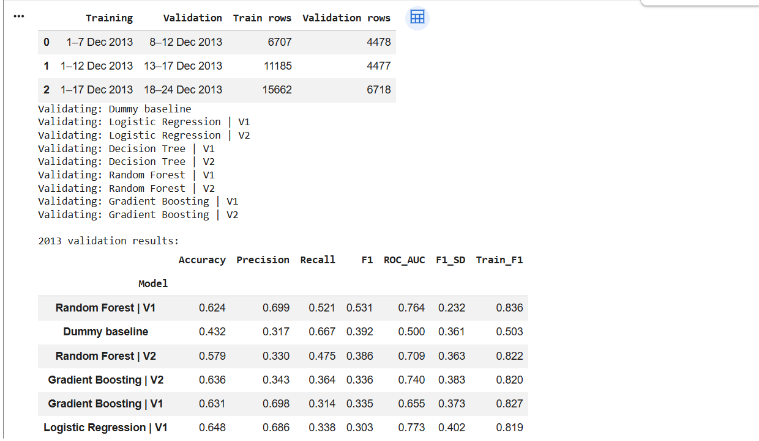

Screenshot D1 Validation periods and the first part of the model comparison.

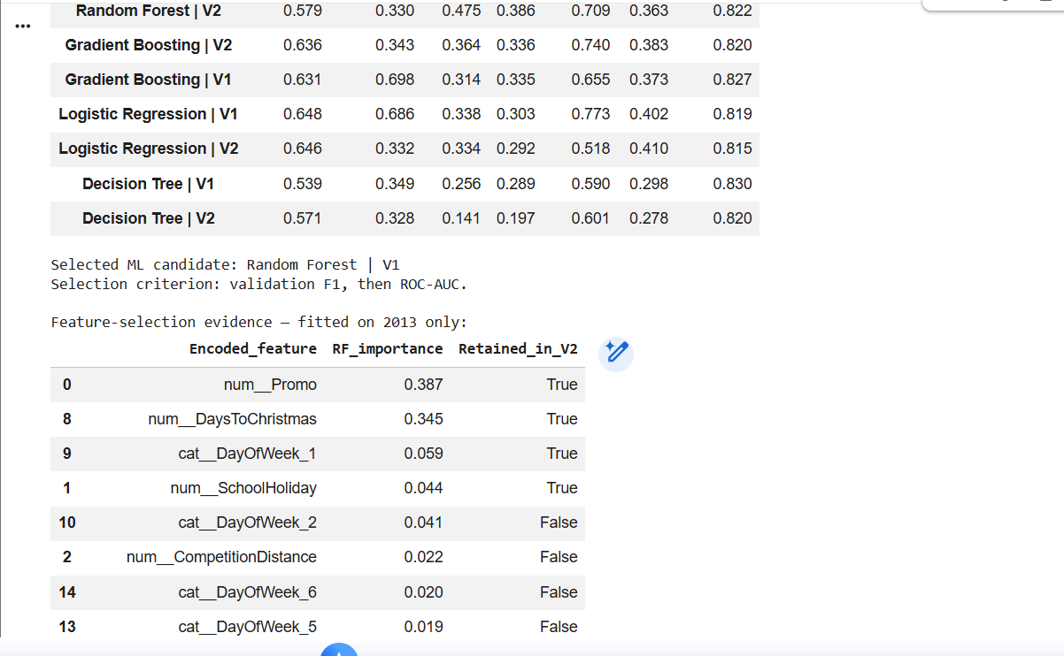
Screenshot D2 Remaining validation results, selected model and the start of the feature-selection audit.

Appendix E Feature and test output
These outputs show the training-only importance audit and final 2014 results. The importance chart is partly visible in the original capture; Figure 1 presents the retained features clearly.
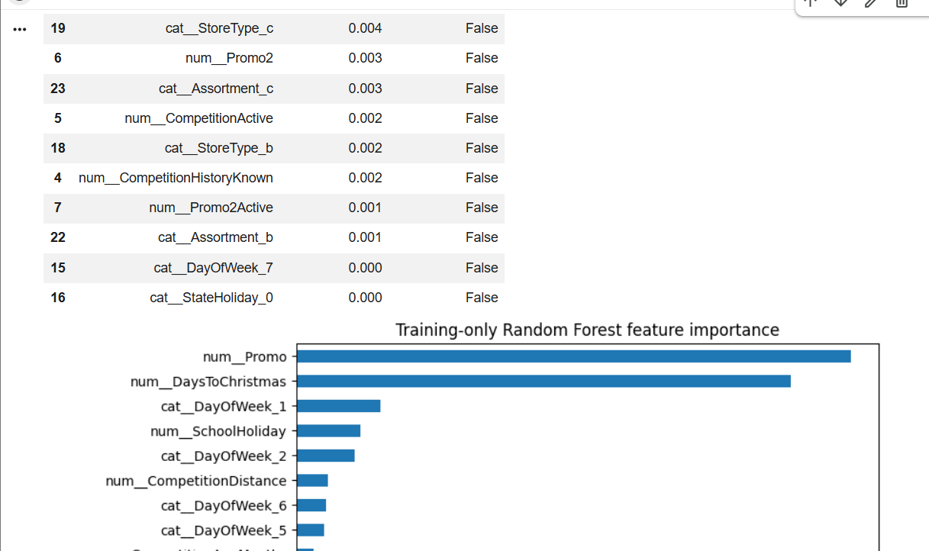
Screenshot E1 Remaining visible feature-selection rows and the importance chart.
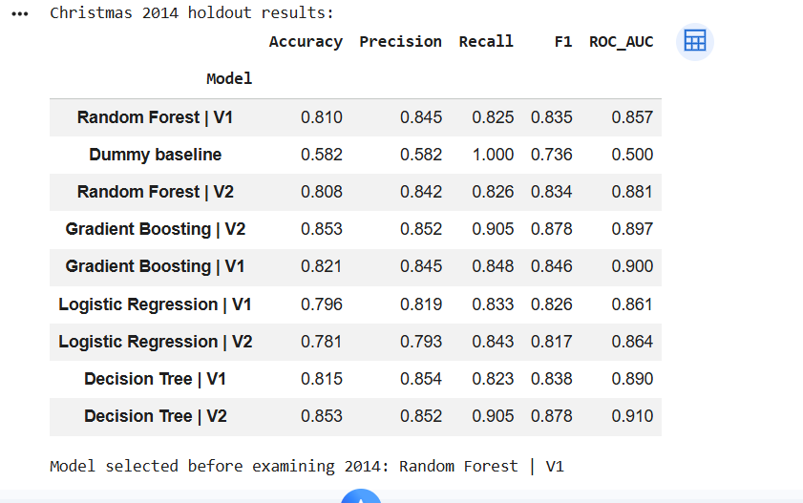
Screenshot E2 Holdout scores and confirmation that Random Forest V1 was selected before the test.

Appendix F Confusion matrix output
The four panels show the validation-preferred version of each algorithm. Rows are actual outcomes and columns are predicted outcomes. The lower-left cell counts missed busy days; the upper-right cell counts false alarms.
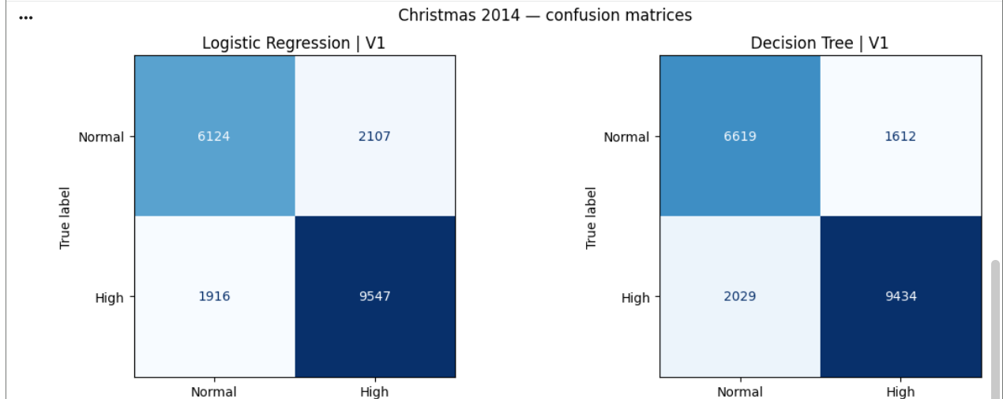

Screenshot F1 Logistic Regression V1 and Decision Tree V1 on the 2014 test.
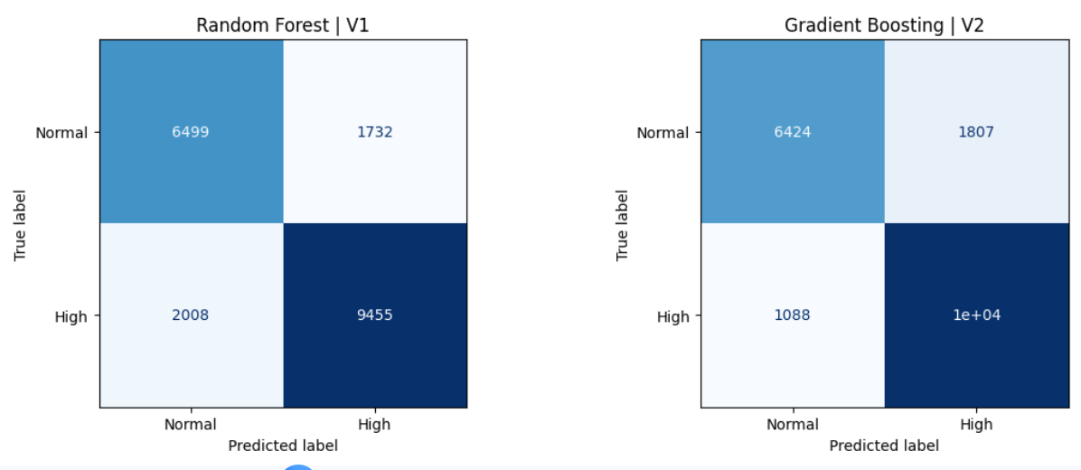
Screenshot F2 Random Forest V1 and Gradient Boosting V2 on the 2014 test.

The Gradient Boosting panel displays one count as “1e+04”, a rounded scientific-notation label. It should not be read as an exact count of 10,000. The Random Forest counts used in Section 5 are fully visible.
The seventh original screenshot, showing the ROC curves, appears as Figure 2 in Section 5 alongside its explanation.

Prompt log
Gemini Ai
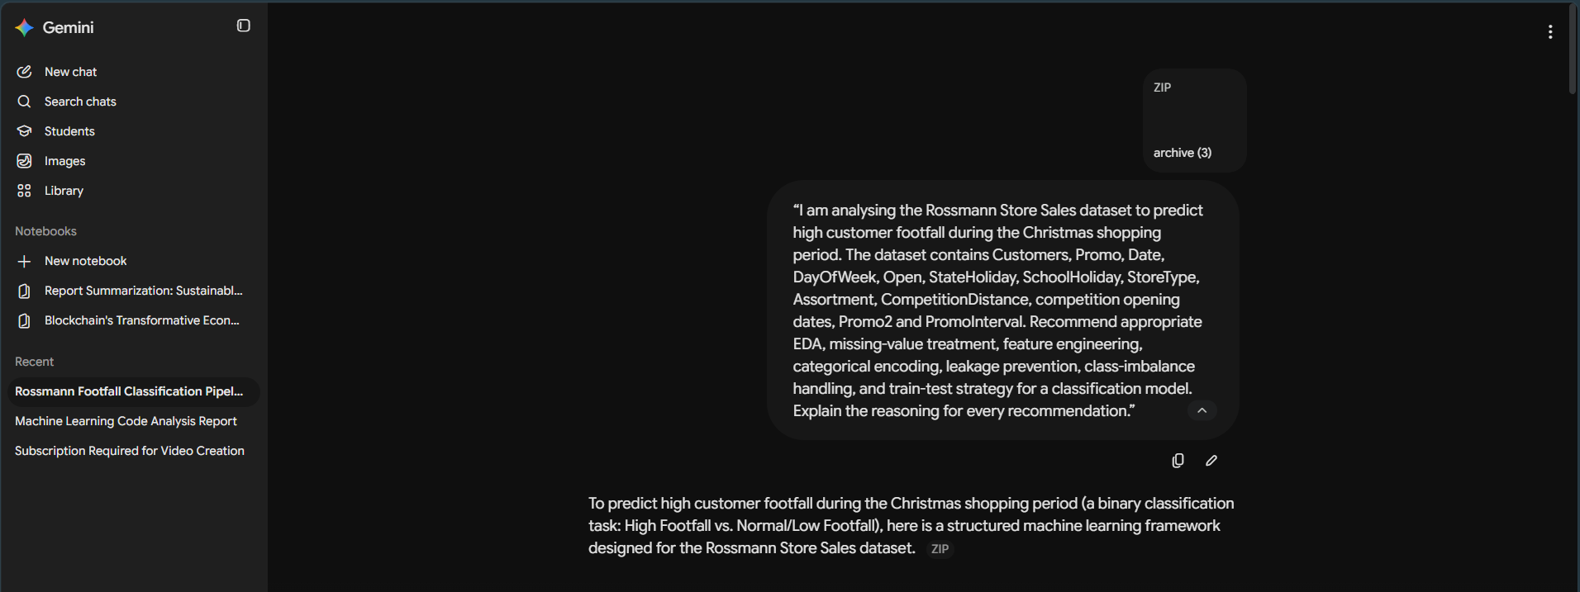
Chatgpt
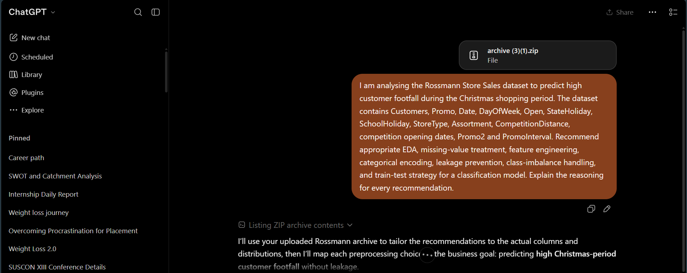
Step 3
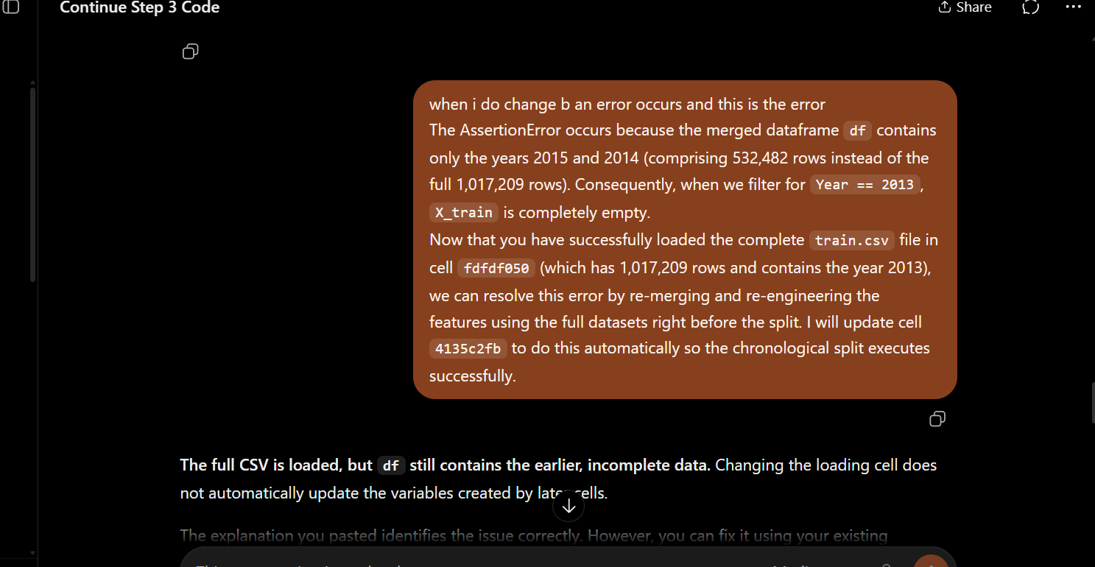

Links for Prompt (A separate file is provided)

https://chatgpt.com/share/6ac67685-0d0c-83ee-9f57-7664e8a8b302
Rossmann Footfall Classification Pipeline Guide - Google Gemini

Kaggle data set link – (Excel sheet is attached in zip folder)
Rossmann Store Sales

